# AWS KMS(Key Management Service)

1. I am creating one bucket and upload simple file

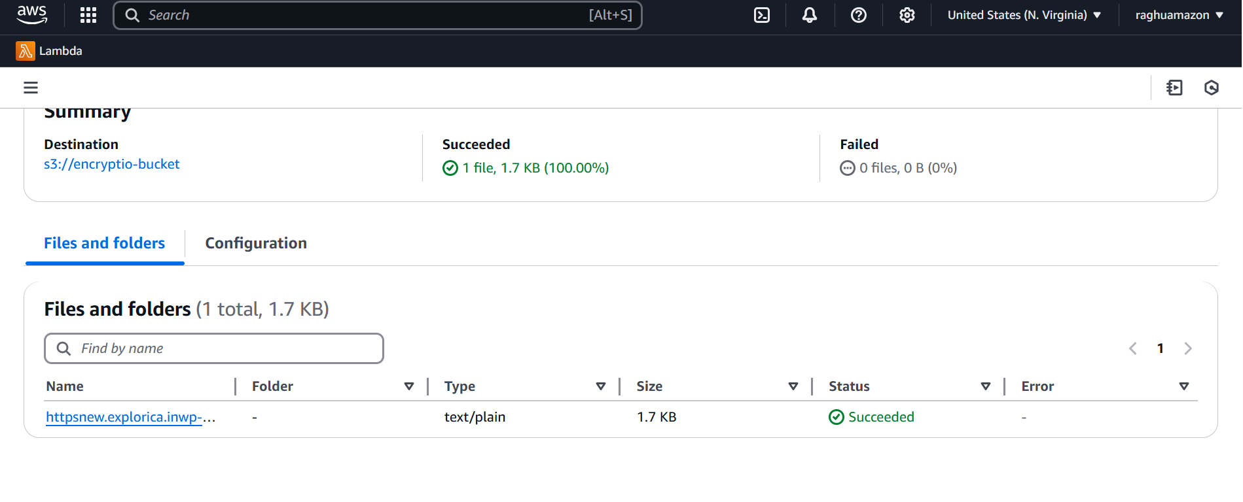

By default the file encrypted with default key (Server-side encryption with Amazon S3 managed keys (SSE-S3))

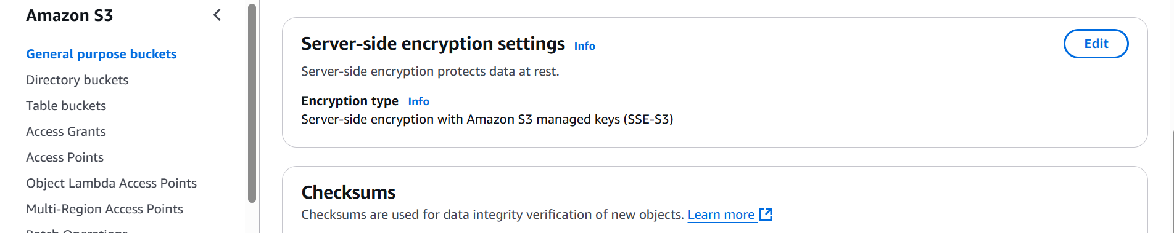

Create a KMS key

